Holiday Cottage Turnaround Service Requirements and Domain Analysis
  - Albin Kastrati | T00255642
SAAD71000 CA1 | Dingle Peninsula Property Care
The proposed system helps staff check whether each cottage can be prepared before the next guest arrives. It brings together current cottage instructions, the time available and the work still to do. The main distinction is between cleaning completion and guest readiness. A completed clean does not make a cottage ready when linen, heating, access, supplies or repairs are still unresolved. Readiness is therefore recorded as a separate decision, based on the available work and inspection reports.
The report turns the holiday cottage scenario into requirements, actor goals, acceptance examples and business concepts. It separates facts stated in the scenario from temporary assumptions and questions that still need answers. The proposed priorities and quality targets need agreement before they become accepted requirements.
Sections 1 to 11 contain the CA1 analysis. Appendix A gives selected user stories and acceptance criteria. Appendix B applies the later lectures through a system sequence diagram, operation contract, responsibility cards and design discussion. These design examples are separate from the conceptual domain model. Appendix C lists the sources. The supporting files include the editable diagrams, acceptance examples and requirement tables.
The main aim is to make current work and unresolved problems clear enough for staff to plan the next steps and for owners to understand progress. The system supports these decisions; people still carry out the work and confirm the missing business rules.

1 Problem evidence and interpretation
Dingle Peninsula Property Care prepares holiday cottages between guest stays. The work includes cleaning, linen, inspection and minor maintenance. Information is currently spread across calendars, messages and paper records. When an owner changes an arrival time, staff may still follow the old plan. A cleaner may also use a copied checklist that no longer matches the cottage. These are problems with shared information as well as with planning. [S: E01-E04]
The main goal is to help the coordinator answer three questions: what needs to be done, how much time and which resources are available, and what is stopping the cottage from being ready? Staff need the latest instructions for their own work. Inspectors need to record problems without making them look solved. Owners need a clear progress report without internal staff notes or information about another owner's cottage. [S: E05-E12]
The proposed system is called HCTS in this report. It supports people making decisions. It does not decide that a cottage is safe or ready just because a task is finished. A readiness decision must use the available work and inspection information. If important information is missing, the gap must remain clear. The evidence list below links later choices to the relevant parts of the scenario.
ID | Scenario section | What the scenario says
E01 | Organisation and current service | Cleaning, linen, inspection and minor maintenance happen between guest stays.
E02 | Organisation and current service | Records are spread across several places, so the latest information can be unclear.
E03 | Properties, stays and turnaround requests | Cottages and service needs differ; old copied checklists may be wrong.
E04 | Properties, stays and turnaround requests | Departure and arrival usually set the working window; either time may change.
E05 | Staff, linen and preparation | Staff have different availability, transport and experience. Teams and provisional assignments are used.
E06 | Staff, linen and preparation | Linen needs depend on guests and beds. Stock may already be packed for another cottage.
E07 | Staff, linen and preparation | Entry details need protection. Temporary staff must not see unrelated owner or guest details.
E08 | Cleaning, inspection and maintenance | Staff record work, linen use and problems. Poor internet may delay reports.
E09 | Cleaning, inspection and maintenance | Inspection may find work needing approval or a specialist.
E10 | Cleaning, inspection and maintenance | A completed clean does not mean the cottage is ready for guests.
E11 | Disruption, handover and information | Changes can require a new plan, extra staff or an owner warning.
E12 | Disruption, handover and information | The coordinator needs progress and problems. Owners must not see internal staff notes.
E13 | Disruption, handover and information | Booking, rent, major contractor management and marketing are outside scope.
E14 | Unresolved matters | Several rules about timing, staff, linen, access, approval and readiness still need answers.

2 Scope and boundaries
The system covers preparation from the time a turnaround is planned until its progress and readiness are reviewed. A turnaround means the work needed to prepare one cottage, usually after one guest leaves and before the next arrives. The system records the working window, tasks, staff assignments, linen needs, reports and decisions. It does not do the cleaning or repairs. Staff still need to carry out the physical work and provide correct information.
Guest booking, rent collection, major contractor management and property marketing are outside scope because the scenario says so. A01 assumes that the coordinator enters information received from letting platforms and the laundry. This is a temporary choice about how information reaches HCTS. It does not mean those organisations have agreed to use this process. Direct links to their systems could be considered later if they are needed.
A02 assumes that owners use HCTS to read progress for their own cottages. The scenario asks for owner progress information but does not say how it must be delivered. Direct access is therefore a proposed requirement based on an assumption, rather than a confirmed company decision. If owners prefer updates through the coordinator, the actor diagram and UC09 would change. The rule that internal staff notes must not be shared with owners would still apply.
The system depends on outside information, including stay times, staff availability, physical linen counts and inspection findings. A record can only be up to date if changes reach it. Poor internet is a stated working condition, so a report may arrive after the work happened. The system should keep both the work time and the time it received the report. This helps people understand a delay and avoids treating the late report as new work.
Type | What it means here
In scope | Cottage instructions, working windows, staff, linen, work and inspection reports, readiness and progress.
Out of scope | Guest booking, rent, major contractor management and marketing. Direct platform and laundry links are excluded under A01.
Depends on | Stay updates, actual staff availability, current cottage details, physical linen counts and work reports.
C01 Scope limit | Keep the scenario exclusions in E13 outside the system.
C02 Working condition | Poor internet may delay reports. The time a report arrives may differ from the time the work happened.
C03 Information limit | Protect entry details. Do not share internal staff notes in owner progress.

3 People organisations and their goals
A stakeholder is a person or organisation affected by the system. An actor is a role that directly uses it. These are not always the same. A guest is affected by an unfinished cottage but does not use HCTS in this analysis. A letting platform supplies stay information, but under A01 the coordinator enters it. The platform is therefore an external stakeholder rather than a direct actor. [L07; L10]
The table records each stakeholder's main goal, needs and influence. The coordinator plans the service, while cleaners and inspectors know what happens at the cottages. Owners influence property preferences and approvals. The laundry coordinator knows about stock and supply. These views should be checked before the requirements are accepted. The roles are taken from the scenario; no interviews have been carried out. Direct roles start use cases and are primary actors. Those with no direct use are offstage stakeholders; no separate supporting system actor is assumed under A01.
Stakeholder | System role | Goal | Influence and needs
SH01 Coordinator | Direct actor | G01 Make a workable plan and spot problems. | Plans the service. Needs current times, staff coverage and reasons a cottage is not ready.
SH02 Cleaner | Direct actor | G02 Do and record the right preparation work. | Knows the practical work. Needs current tasks and reports that are not lost without internet.
SH03 Inspector | Direct actor | G03 Record findings and leave unfinished work clear. | Supplies important checks. Permission to decide readiness is still open.
SH04 Temporary worker | Direct actor | G04 Get entry and task details for assigned work. | Needs useful instructions without unrelated personal information.
SH05 Owner | External; direct actor under A02 | G05 Understand progress and the effect of changed times. | Influences preferences and approvals. Needs a clear cottage summary.
SH06 Laundry coordinator | External; no direct use under A01 | G06 Avoid promising the same linen twice. | Knows linen supply. The coordinator enters updates in this analysis.
SH07 Letting platform | External; no direct use under A01 | G07 Supply current stay information. | Its updates affect working windows. No direct system link is assumed.
SH08 Guest | Affected; no direct use | G08 Arrive at a ready cottage with personal details protected. | Affected by delays and missing preparation. Does not use HCTS in this analysis.
SH09 Maintenance specialist | External; no direct use | G09 Receive problems needing specialist work. | Unfinished work may prevent readiness. Contractor management is outside scope.

A role is not a separate person. One staff member might clean on one job and inspect another. This is why the later domain model uses StaffMember with roles, rather than creating a different kind of person for every job title. The actor diagram still shows the roles separately because each has a different reason for using the system. The distinction helps keep the use cases about people's goals and the domain model about the information that must be kept.

4 Proposed requirements
A functional requirement describes something the system needs to do. Each requirement below has an ID, a priority, a source and a way to check it. The source points to the scenario evidence list. An A reference shows where a requirement depends on an assumption. This makes it possible to explain why a requirement exists and what needs to change if the assumption is wrong. The proposed checks give clear outcomes to review with the people involved. [L07; L10]
The priorities use the lecture's MoSCoW method. Must means needed for the proposed first version. Should means important, but the basic service could work without it for a short time. Could means useful if time allows. Won't means outside this version. The first ten requirements are Must because current instructions, resources and work records support a trustworthy readiness decision. The two summary views are Should because the coordinator could initially pass on updates. These priorities still need agreement.
ID / priority | What the system should do | Source and proposed check
FR01 Must | HCTS must keep the current and earlier versions of each cottage's setup, preferences and agreed service package. | E03; A03  Check: Change the bed setup. Check that the new details and the earlier version can both be read.
FR02 Must | HCTS must show the time between departure and arrival for each turnaround, mark missing or unconfirmed times, and show time changes since the latest readiness decision. | E02, E04, E11; A04  Check: Change arrival from 16:00 to 13:00. Check the new window and that readiness needs review (GH02).
FR03 Must | HCTS must prepare the task checklist using the current cottage setup and mark an existing checklist for review if its setup is old. | E03; A03  Check: Change setup version 2 to 3. Check the old checklist is marked for review and completed work is kept (GH04).
FR04 Must | HCTS must record staff assigned to each turnaround, whether each assignment is provisional or confirmed, and the availability, transport and experience used to plan it. | E05; A05  Check: Assign two people. Leave one assignment provisional and confirm the other. Check that both states are shown.
FR05 Must | HCTS must record the linen type and quantity needed for each turnaround, with the guest numbers and bed setup used to work out that need. | E06; Q04  Check: Record a need for 8 double-sheet sets and its guest and bed details. Check that all values are kept. This does not assume an agreed calculation rule.
FR06 Must | HCTS must only confirm a linen reservation if enough of the chosen stock is still free. | E06; A06, BR03  Check: With 10 sets on hand and 6 reserved, check that a request for 4 succeeds and a request for 5 does not (GH03).
FR07 Must | HCTS must give staff current entry and task instructions only for work allowed by their role and assignment. | E07; A07, BR05  Check: The temporary worker assigned to T104 receives its instructions but no unrelated cottage, owner or guest details (GH05).
FR08 Must | HCTS must keep work reports about tasks, linen used and problems, and show whether a report is waiting on the worker's device or has reached the shared record. | E08; C02, Q07  Check: Record a report without internet and send it later. Keep the work and received times. Sending it again must not add a second copy.
FR09 Must | HCTS must keep inspection results and show whether each reported problem has been resolved. | E09; BR06  Check: Record an unresolved repair problem. Check that completing cleaning does not close the problem.
FR10 Must | HCTS must save a permitted readiness decision separately from cleaning completion, with the information time and any reasons for outstanding work. | E10; A04, A08, BR04  Check: Save Not ready because linen is missing (GH01). Also check that Ready cannot be saved while that problem remains (UC08, 4b).
FR11 Should | HCTS should show the coordinator upcoming windows, unconfirmed times, staff coverage, linen shortages, unfinished inspections and readiness problems. | E11, E12  Check: Create one example of each listed problem. Check that the affected turnaround and the reason appear in the summary.
FR12 Should | HCTS should show owners the progress and timing risks for their own cottages, without internal staff notes. | E12; A02, A07  Check: An owner of P01 sees its progress and timing risk, but cannot read P02 progress or internal staff notes.

Quality requirements and proposed checks
A quality requirement describes how well the system should work. Words such as fast, secure or reliable are too vague on their own. The targets below give a clear condition and a result that could be checked. The scenario supports the need for restricted access, useful response times and reliable delayed reports. It does not supply the numbers. All numerical targets below are proposed for discussion and need agreement before they become accepted requirements.
Quality | Priority / source | Proposed target | How to check it
NFR01 Information access | Must; E07, E12; A07 needs agreement | For every case in the agreed role and assignment access list, show zero forbidden details or unrelated records. This also applies when someone asks directly for a known record. | Check allowed and refused requests. Include a removed assignment and an owner asking for another owner's cottage.
NFR02 Response time | Should; E11, E12; proposed target | At least 95 of 100 coordinator summary requests must finish within 3 seconds, with 200 upcoming turnarounds and 10 people using the system at the same time on an agreed test network. | Time 100 requests under these conditions. Keep the times and network details. Agree the target before using it.
NFR03 Reports without internet | Must; E08; proposed target | During a 2-hour loss of internet, keep 50 trial reports. All 50 must still be available after closing and reopening the app. After accepted delivery, each must appear once in the shared record, including 10 repeat sends. | Record the reports without internet, reopen the app, reconnect and send again. Compare the device reports with the shared records. Saving reports on the device is a proposal.
NFR04 Up-to-date information | Must; E02, E04, E11; proposed target | For 20 accepted time or readiness changes, every permitted connected view must show the new value or an out-of-date warning within 30 seconds. Without internet, it must show when it last received an accepted update. | Check coordinator and owner views after each change and while disconnected. Compare all 20 changes with the proposed time limit.

The access test needs an agreed list showing which role can see which information. The speed test needs an agreed test network and workload. The delayed-report test proposes keeping reports on the worker's device until they can be sent; the scenario does not promise that this already exists. The freshness test checks whether people can tell that information has changed or may be old. None of these tests has been run against an application, because this work is an analysis example.

5 Rules assumptions and unanswered questions
A business rule states a condition that the service must follow. The six rules below are supported by the scenario. They are written separately from features so that the same rule can guide several use cases. For example, the difference between clean and ready affects both inspection and owner progress. A rule may be clear in general but still need detail. The scenario establishes that unresolved work can prevent readiness, but it does not give a complete list of readiness checks.
ID | Rule supported by the scenario | Source and limits
BR01 | When both linked stay times are known, departure and arrival set the time available for the turnaround. | E04. Missing links or times must remain clear.
BR02 | Preparation instructions must match the cottage's current setup and agreed service needs. | E03. How changes are approved still needs an answer.
BR03 | Linen needs depend on guests and beds. Linen packed for another cottage is not free for a new job. | E06. The exact calculation and reservation rules need agreement.
BR04 | Cleaning alone does not make a cottage ready. Linen, heating, access, supplies or repairs can still prevent readiness. | E10. The full list of required checks needs agreement.
BR05 | Temporary workers get relevant entry and task details, without unrelated owner or guest details. Owners do not get internal staff notes. | E07, E12. Exact information access needs agreement.
BR06 | Recording a problem does not mean that the problem has been fixed. | E09. It may remain open after that turnaround.

The lecturer guidance says that the unanswered matters are deliberate. An analyst should identify the gap, explain its effect and make any temporary choice clear. An assumption allows an example to continue; it does not settle the issue. A question asks someone to supply missing information. A constraint is a limit already stated. A risk is something that could go wrong. A business rule needing confirmation is a proposed policy that must be agreed before it is used. The table below shows how these labels apply here. [T]
Label | Meaning | Example in this scenario
Assumption | A temporary answer that lets the analysis continue. It needs confirmation. | A02: owners read their progress directly in HCTS. Q08 checks this.
Clarification question | A missing answer to ask the relevant person. | Q03: how long can a staff assignment remain provisional? No duration is invented.
Constraint | A limit or working condition already stated. | C02: poor internet may delay reports.
Risk | Something that could go wrong because of a gap or working condition. | R01: a delayed report could make an earlier Ready decision wrong.
Business rule needing confirmation | A proposed policy that must not be treated as agreed. | A08: the coordinator may record readiness using the proposed checks. Q06 must confirm authority and evidence.

ID | Temporary choice | Needs checking / links
A01 | For this analysis, the coordinator enters updates from letting platforms and the laundry. There is no direct link to their systems. | Unconfirmed. Q01; scope and actors.
A02 | For this analysis, owners read their own cottage progress directly in HCTS. | Unconfirmed. Q08; SH05, UC09, FR12.
A03 | Keep versions of cottage preparation details and the version used for each task. If details change, mark old checklists for review and keep work already recorded. | Unconfirmed. Q02; FR01, FR03, PropertySetup, Task.
A04 | Changed relevant times or newly received problems that prevent readiness require review of an earlier Ready decision. Unconfirmed times prevent a new Ready decision. | Proposed rule; needs confirmation. Q01, Q06; FR02, FR10, GH02.
A05 | Each cottage has one responsible owner. A turnaround can be planned before either stay is linked. Each stay is the departure for at most one turnaround and arrival for at most one other. A person confirms a staff assignment. No expiry time is assumed. | Unconfirmed. Q03, Q09; diagram numbers and FR04.
A06 | An active linen reservation reduces free stock. Reservations cannot exceed stock on hand, even if requests arrive together. A smaller reservation needs a new, smaller request. | Proposed rule; needs confirmation. Q04; FR06, GH03.
A07 | Staff access depends on current role and assignment. Owners see only their own cottage summary. Exact details and when access ends remain open. | Unconfirmed. Q05, Q08; FR07, FR12, NFR01.
A08 | The coordinator may record readiness. Ready needs confirmed current times, the agreed checks and no known problem preventing readiness. Otherwise record Not ready or Needs review, with reasons. | Proposed rule; needs confirmation. Q06; FR10, UC08, GH01.

ID | What could go wrong | How to reduce the risk
R01 | A late or conflicting report could make an earlier Ready decision wrong. | Keep work and received times. Review affected decisions. Q01, Q07.
R02 | Unclear linen units or reservation rules could promise the same stock twice. | Agree the units and when reservations start and end. Check requests made at the same time. Q04.
R03 | A worker or owner could receive private information they do not need. | Agree who may see each detail. Check refused requests as well as allowed ones. Q05, Q08.
R04 | Pressure from an early arrival could lead to work being skipped or a repair approved by the wrong person. | Keep the unfinished-work reason visible and show the timing risk. Agree who can approve changes. Q06.

All A01-A08 entries are unconfirmed. They are useful for showing how the analysis would work, but a stakeholder could change them. No expiry period is invented for a provisional staff assignment. Q03 asks how long it can remain provisional and who can confirm, change or withdraw it. The lecturer's example of five working days concerned a different setting and is not a cottage-service rule. Questions about information sharing are also kept open where the scenario does not give the exact answer.
ID | Who to ask | Question
Q01 | Coordinator and owner | Which stay-time source is trusted if times conflict? Must a change reopen readiness and trigger an owner update? What happens if arrival is at or before departure?
Q02 | Cleaner and coordinator | Who approves changes to the cottage setup? How should an old checklist be updated without losing completed work?
Q03 | Coordinator | Who can confirm, change or withdraw a provisional assignment? How long may it stay provisional? How are overlapping jobs, travel, illness and team coverage checked?
Q04 | Laundry coordinator | What units and guest/bed rules determine linen need? When is linen reserved, packed, released, used or replaced? When may expected deliveries count as available?
Q05 | Coordinator and temporary worker | Which details may temporary workers see, and for how long? What happens to old entry details already downloaded when an assignment ends or changes?
Q06 | Coordinator, inspector and owner | Who may decide readiness, shorten or skip tasks, or approve minor repairs? Which problems prevent readiness, and what information is required before deciding?
Q07 | Cleaner and inspector | How are delayed reports with conflicting information handled? Who must receive reports of damage, missing items or repairs, and how is receipt confirmed?
Q08 | Owner | Do owners want a direct progress view or updates through the coordinator? Which details and channels may be used, while keeping internal staff notes private?
Q09 | Coordinator and owner | Can a cottage have more than one owner or a shared access contact? Can a turnaround happen outside normal guest changeovers? Can one stay link to more than one turnaround at either end?

6 Use cases meaningful business actions
A use case describes how an actor reaches a goal through the system. Its steps should explain the business interaction: who acts, what starts it, what information is supplied and what result is returned. They should not list button presses or screen layouts. The catalogue below gives the main goal of each use case. UC08 is then described in detail because deciding whether a cottage is ready brings together timing, work, linen, inspection and unresolved problems. [L04; T]
Use case | Main actor | Goals / requirements | Useful result
UC01 Update cottage preparation details | Coordinator | G01, G02; FR01 | Current cottage details are saved, with earlier versions kept.
UC02 Plan or change a turnaround | Coordinator | G01, G05; FR02, FR03 | Stay links, working times and any checklist review are shown.
UC03 Assign staff | Coordinator | G01, G02; FR04 | Staff assignments are recorded as provisional or confirmed.
UC04 Plan and reserve linen | Coordinator | G01, G06; FR05, FR06 | Linen need is recorded and only free stock is reserved.
UC05 Get assigned work instructions | Cleaner, temporary worker | G02, G04; FR07 | The worker gets current entry and task details they may see.
UC06 Record work done | Cleaner, temporary worker | G02; FR08 | Work and problems are recorded, with delivery status clear.
UC07 Record inspection results | Inspector | G03; FR09 | Results and unresolved problems are saved.
UC08 Decide whether the cottage is ready | Coordinator under A08 | G01, G05, G08; FR10 | A supported decision is saved, or reasons for refusal are given.
UC09 Check progress and problems | Coordinator; owner under A02 | G01, G05; FR11, FR12 | Each role sees the progress and timing risks it may read.

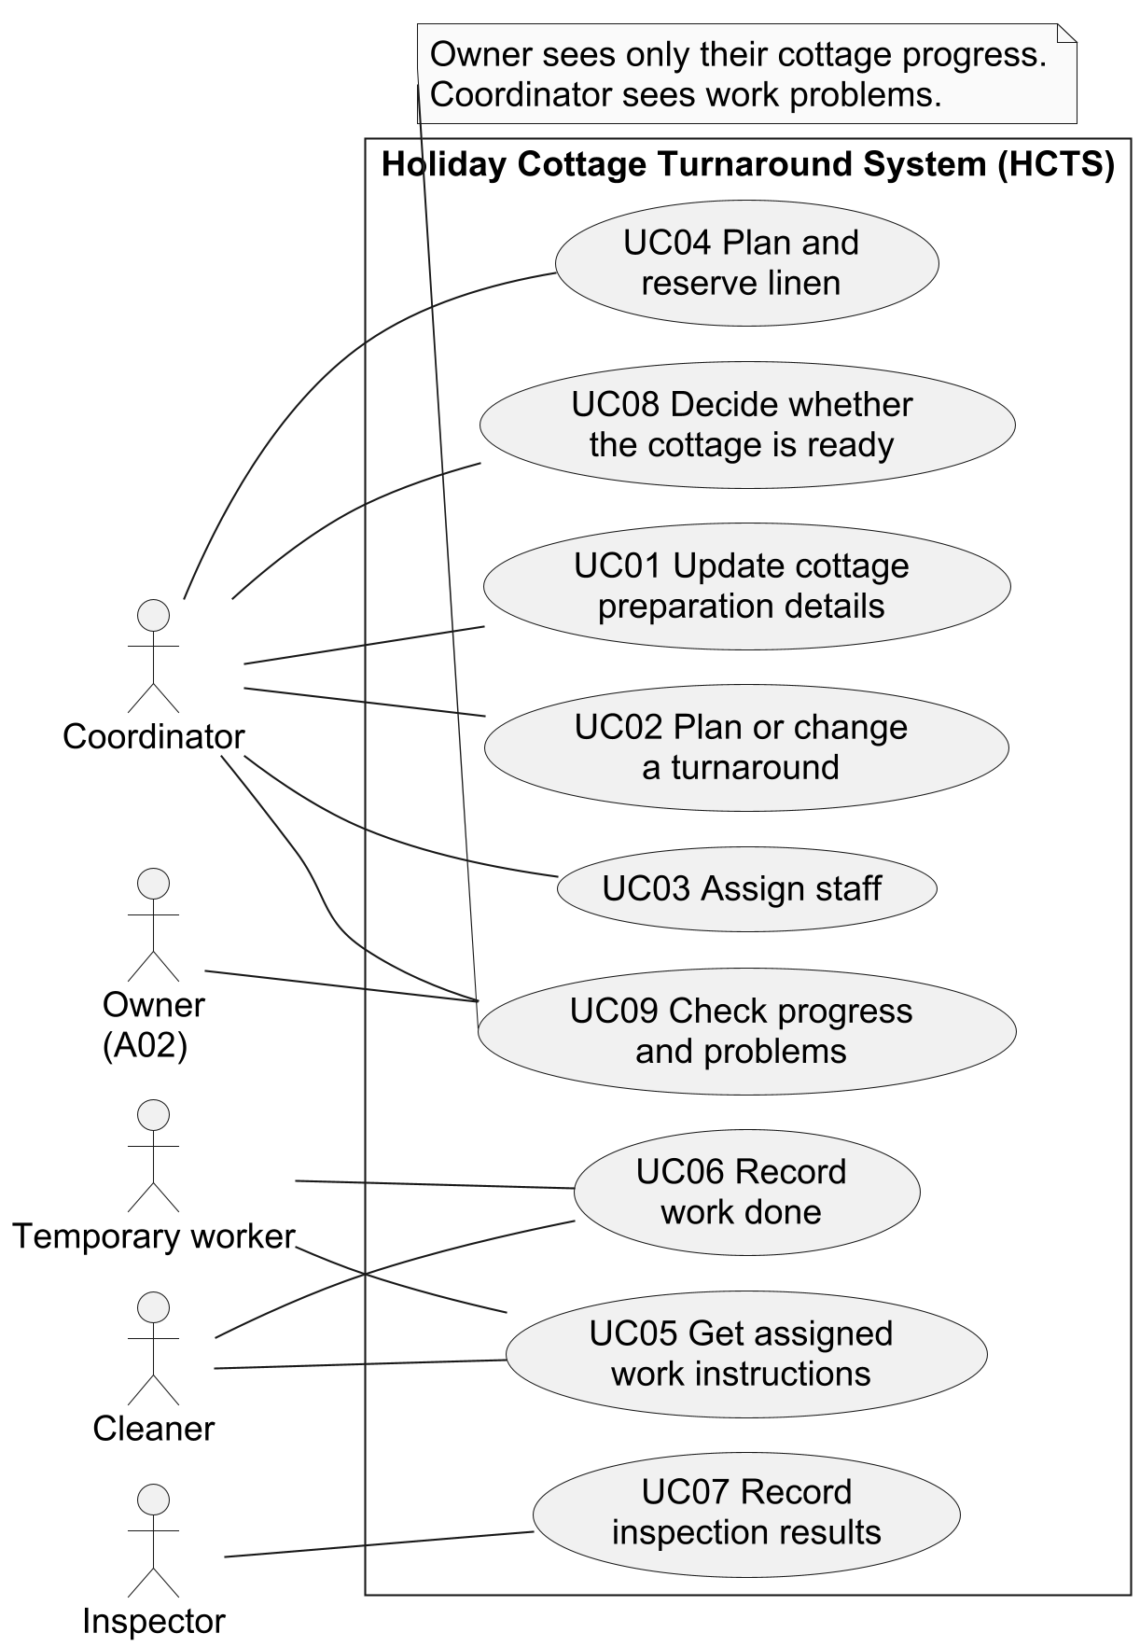
Use-case diagram: who uses HCTS and why. Owner access depends on A02; readiness permission depends on A08.

Detailed use case UC08 Decide whether the cottage is ready
Scope: HCTS. Level: one user goal.
Main actor: The coordinator, assuming A08 is agreed.
Other people involved: The owner and guest need a correct readiness result. Staff and inspectors need their reports to stay accurate.
Trigger: The coordinator asks to review one turnaround for readiness.
Preconditions: The turnaround exists and the coordinator is identified. Permission is checked during the steps. Completed cleaning, a finished inspection and no outstanding problems are not preconditions, because this use case must handle their absence.
Postconditions after success: A readiness decision is saved with the person who made it, the information time and any reasons. The main path records Ready. Other valid paths record Not ready or Needs review.
Minimum result if the process cannot finish: No unsupported Ready decision is saved. Earlier work and decisions are kept. A failure to save is clearly reported.
Special requirements: NFR01 controls access to information. NFR04 covers how quickly changes appear. Poor internet may limit what is known at the time.
Step | Main path: the cottage is ready
1 | The coordinator identifies the turnaround to review.
2 | HCTS checks permission and gives the current times, tasks, linen position, inspection results and unresolved problems. It shows known waiting reports and when the shared information was last updated.
3 | The coordinator reviews this information and asks to record Ready, referring to the information time reviewed.
4 | HCTS checks that the information has not changed and that the readiness rules in A08 are met.
5 | With confirmed times, the required checks complete and no known problem preventing readiness, HCTS saves the Ready decision, its information time and the person who made it.
6 | HCTS confirms the saved decision and information time. Progress summaries show the new result to people who may see it.

Path | Situation | What happens next
2a | The coordinator lacks permission. | HCTS refuses the request without showing restricted details. No new decision is saved. End.
2b | A known waiting report, missing time or unfinished inspection leaves required information missing. | HCTS explains the gap. The coordinator may record Needs review with reasons, or cancel. Steps 4-5 still check current information and save any chosen decision. End through step 6; never save Ready on this path.
3a | The information is sufficient to identify a problem, and the coordinator chooses Not ready. | The coordinator gives the reason. Continue at step 4 to check current information, then save Not ready at step 5 and confirm at step 6.
3b | The coordinator cancels. | Save no new decision. Keep earlier reports and decisions. End.
4a | Relevant times or reports changed after step 2. | Do not save the decision based on old information. Explain the changes and return to step 2.
4b | Ready was requested but a known problem prevents it. | Do not save Ready. Explain the problem. Return to step 3 so the coordinator can choose Not ready or Needs review with reasons, or cancel. Any new request must pass the current-information check.
5a | HCTS cannot save the decision. | State that it was not saved. Do not claim success. The coordinator must review current information before trying again. End.

The numbered steps describe meaningful actions, such as reviewing work information and recording a decision. They do not describe clicking a button. The alternative paths matter as much as the main path. Recording Not ready because linen is missing is a useful result: it explains what must be fixed. Missing reports are different from a known problem, so they lead to Needs review rather than a claim that everything has been checked. Permission and the required readiness checks remain open under A08 and Q06. [L04; T]

7 Acceptance examples
Acceptance examples show what a requirement means in a specific case. The lecture format uses Given for the starting situation, When for the action and Then for the expected result. The examples cover successful recording, a change that needs review, a stock limit, old instructions and restricted access. The linen example tries both the exact remaining quantity and one more than that quantity. This checks the boundary instead of using only an easy case with plenty of stock. [L04]
Feature: Plan cottage preparation using current information
# Made-up test data. A tags mark assumptions that still need agreement.
@GH01 @FR09 @FR10 @UC07 @UC08 @BR04 @BR06 @A08
Scenario: A clean cottage is not ready when linen is missing
Given T100 has confirmed times and completed cleaning
And its inspection records missing linen as an unresolved problem preventing readiness
When the coordinator with permission records T100 as not ready
Then its readiness is "Not ready" with reason "Missing linen"
And its cleaning remains "Complete"
And the unresolved inspection finding is kept
@GH02 @FR02 @FR10 @UC02 @UC08 @A04
Scenario: An earlier arrival requires a new readiness review
Given T101 has departure at 10:00 and confirmed arrival at 16:00 on the same day
And T101 has a Ready decision based on those times
When the coordinator changes the confirmed arrival to 13:00
Then the working window is 10:00 to 13:00
And the earlier Ready decision is kept in the history
And the current readiness is "Needs review" because the time changed
@GH03 @FR06 @UC04 @BR03 @A06
Scenario Outline: Linen reservations cannot exceed free stock
Given stock L1 contains 10 double-sheet sets
And 6 sets are actively reserved for another turnaround
When the coordinator requests <requested> sets from L1 for T102
Then the new reservation is <outcome>
And <remaining> sets remain free in L1
Examples:
| requested | outcome | remaining |
| 4 | confirmed | 0 |
| 5 | not confirmed | 4 |
@GH04 @FR01 @FR03 @UC01 @UC02 @BR02 @A03
Scenario: Changed cottage details require a checklist review
Given T103 has a checklist based on cottage P03 setup version 2
And one task on that checklist is complete
When the coordinator records version 3 with changed bed details
Then T103's checklist is marked "Review required"
And the completed task and its link to version 2 are kept
@GH05 @FR07 @UC05 @BR05 @A07
Scenario: A temporary worker gets only the work details they may see
Given temporary worker W07 is assigned to T104 at cottage P04
And W07 has no assignment at cottage P05
When W07 asks for preparation details for P04 and P05
Then W07 receives current entry and task instructions for T104
And W07 receives no preparation details for P05
And W07 receives no unrelated owner or guest details
The editable source is features/turnaround.feature. There are five scenario definitions. The linen outline has two rows, so it describes two separate runs and gives six runs in total. These are proposed acceptance examples, not evidence that a system has passed tests. The numbers, references and times are made-up test data. The A tags show which expected results depend on unconfirmed rules. There is no automatic expiry test because the assignment expiry rule has not been agreed.

8 Finding the main concepts
The object-finding lecture starts with possible concepts from the problem description, then checks which ones deserve a place in the model. A noun does not automatically become a class. Some nouns describe a value, some describe a role and some name a tool currently used to hold information. The table shows which candidates are kept, combined, turned into attributes or removed. An attribute is a detail kept about something, such as a stay's arrival time. [L06]
Possible concept | What it represents | Decision | Reason
Owner; Property; Stay | People, places and guest stays | Keep all three | They have different meanings: responsibility, cottage identity and stay times. E03, E04.
Turnaround; turnaround request | Preparation work for one cottage | Keep Turnaround; combine the two terms | The scenario does not require a separately tracked request. E04, E05.
Property setup; seasonal setup | Details that can change | Keep PropertySetup | A03 keeps the version used to make a checklist. E03.
Room; bed; furniture; facilities | Details of the setup | Convert to PropertySetup attributes | Separate room and bed records are not needed for these examples. Revisit if tasks must be tracked room by room. E03.
Service package; owner preference | Preparation details | Convert to PropertySetup attributes | The scenario does not describe a separately managed package list. E03.
Checklist; task | A group of tasks; one piece of work | Keep Task; checklist means a turnaround's tasks | Each task needs an outcome. A separate checklist record is not yet needed. E03, E08.
Cleaner; inspector; temporary worker | Staff roles | Merge person details into StaffMember | A person can have more than one role. E05, E07, E08.
Assignment; team | Staff linked to jobs | Keep Assignment; team means several assignments | Each person's assignment can be provisional or confirmed. E05.
Linen; stock; linen location | Available supply | Keep LinenStock | Type and location identify the stock that can be reserved. E06.
Linen need; reservation | Needed supply; supply set aside | Keep LinenRequirement and LinenReservation | What is needed may differ from what has been reserved. E06.
Inspection; damage; missing item; repair issue | A check and its problems | Keep Inspection; combine problem types as Concern | Problems may come from work or inspection and may remain unresolved. E08, E09.
Readiness; readiness decision; cleaning completion | A decision and a work state | Keep ReadinessAssessment; put cleaning state on Turnaround | Keep who decided, when and why. Do not confuse a clean cottage with a ready one. E10.
Window; arrival; departure | A time span and two time values | Convert times to Stay attributes; work out the window | The window comes from the times, so it is not a separately edited class. E04.
Key; code; alarm detail | Entry instructions | Convert to Property accessInstructions | Tracking each physical key is not required by the scenario. Entry details still need protection. E07.
Calendar; message; paper checklist | Ways records are currently kept | Remove as classes | Model the business information rather than the tool holding it. E02.
Shorten; approve; pass on a problem | Actions and rules needing answers | Remove as classes; keep questions | An action word does not by itself describe a thing to record. Q06, Q07.
Letting platform; laundry; guest | Outside stakeholders | Remove from this model | Stay and stock facts are enough for the assumed manual updates. E04, E06; A01.
Rent; marketing; contractor contract | Excluded work | Remove | Outside the stated scope. E13.

Fourteen concepts are kept. PropertySetup holds a version of the preparation details; this follows assumption A03. Assignment is separate from StaffMember because one person can have several jobs, each with its own confirmation state. LinenRequirement, LinenStock and LinenReservation are separate because need, supply and promised supply can differ. ReadinessAssessment records a decision and its reasons. Removing a candidate from this model does not mean it is unimportant; it means a separate class is not needed for the chosen part of the problem.

9 Domain model the things the service records
A conceptual domain model shows the important things in the business and how they relate. It does not show screens, database tables or software services. Each box is a class, meaning a kind of thing the system needs to understand. The words inside are its attributes. A line names a relationship. The numbers show how many items can be linked: 1 means exactly one, 0..1 means none or one, and 0..* means any number, including none. [L05; L19]

Domain model
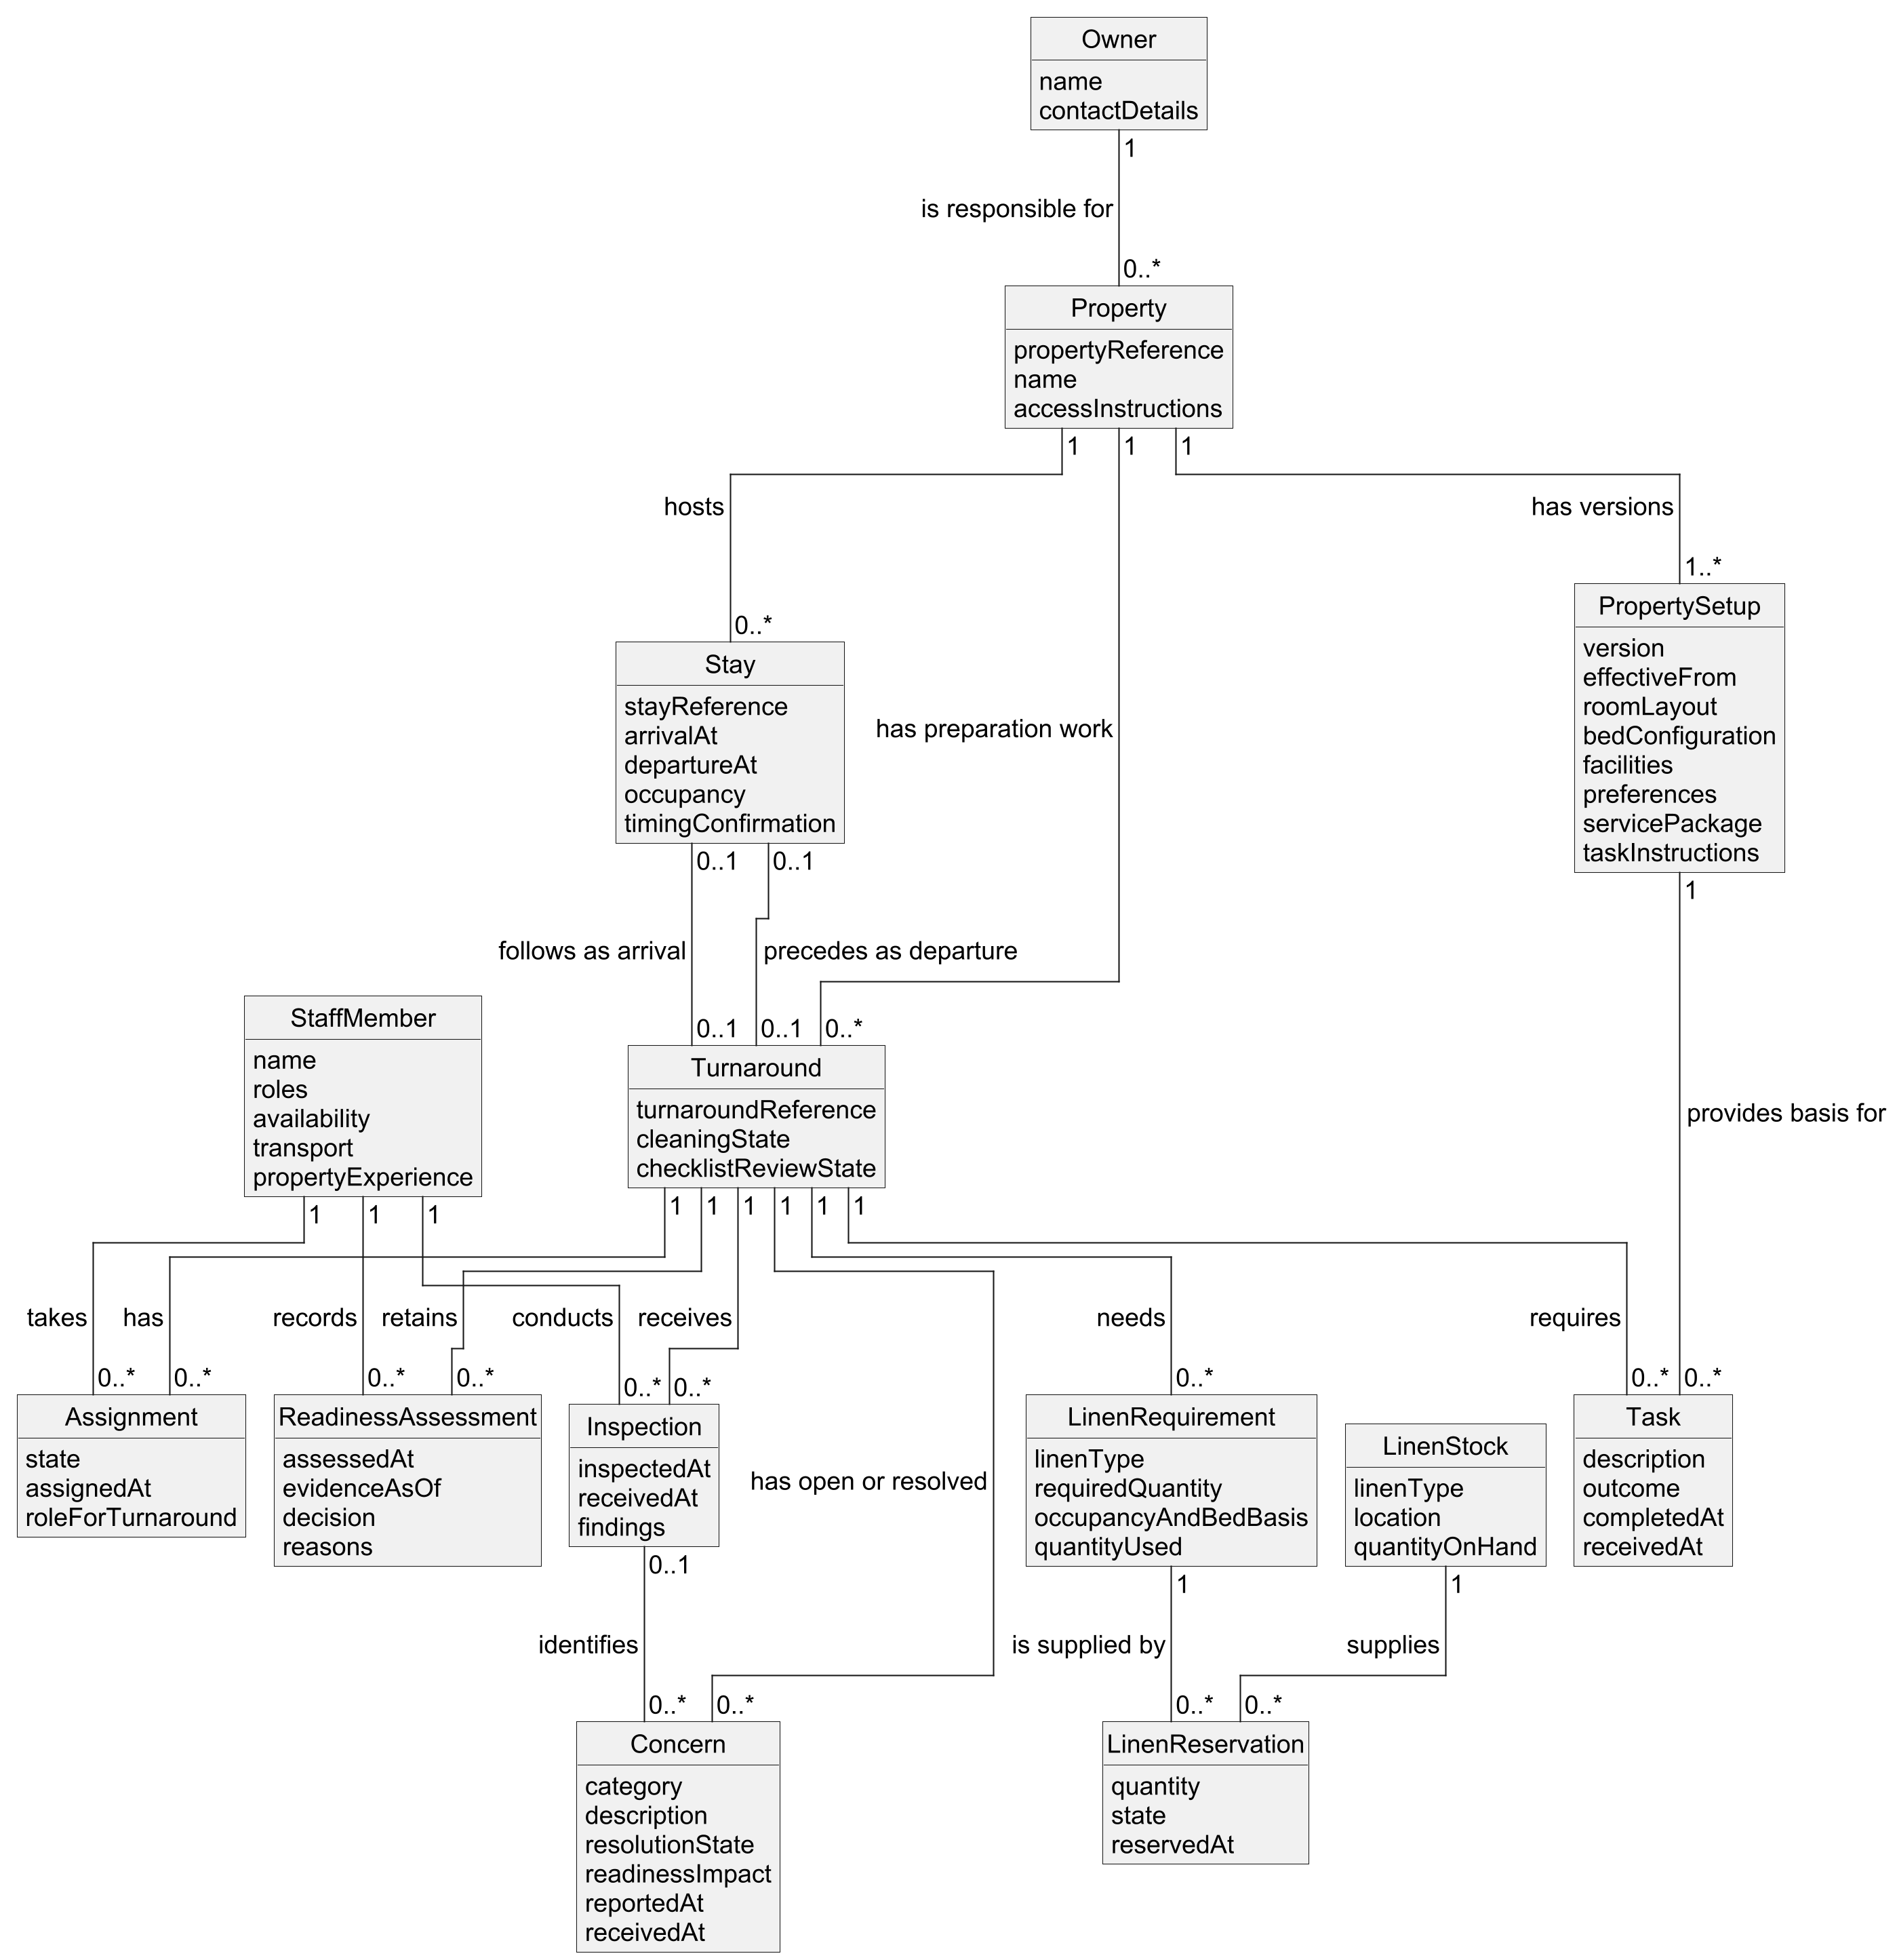
Domain model: 14 business concepts, their details and relationships. The numbers on the links are explained in Section 9. No software methods are included.
Lines that cross do not create extra relationships. Section 9 explains the optional stay links and the one-owner assumption.

Under A05, each Property has one responsible Owner and each owner may have several properties. Each property has at least one PropertySetup version. A Turnaround can be planned before either stay is known, so its departing and arriving stay links are optional. Each stay can be the departing stay for at most one turnaround and the arriving stay for at most one other turnaround. These limits are temporary choices to check in Q09, especially if there are shared owners or work outside normal guest changeovers.
Each LinenRequirement belongs to one turnaround. It can be met by several LinenReservation records, and each reservation takes a quantity from one LinenStock record. A stock record identifies the linen type and its location. Under A06, free stock is the quantity on hand minus active reservations. The total active reservations must not exceed the quantity on hand. For example, ten sets on hand with six reserved leaves four free. The exact rules for releasing reservations and recording used linen remain in Q04.
A turnaround may have several inspections and several readiness decisions over time. A concern can come from an inspection or be reported during other work, so its inspection link is optional. A recorded concern stays open until it is resolved; simply writing it down does not fix it. Readiness decisions keep their history even when later information makes a review necessary. Cleaning completion remains a separate fact. This structure helps explain how a cottage can be clean, have a completed inspection and still be Not ready.
Term | Plain meaning
Owner | Person responsible for a cottage. One owner per cottage is assumption A05.
Property | A holiday cottage with its own identity and current entry instructions.
PropertySetup | One version of the cottage's rooms, beds, facilities, preferences, package and preparation instructions.
Stay | A guest stay with arrival, departure, guest numbers and time confirmation. This does not sell or book the stay.
Turnaround | The work to prepare one cottage, usually between guest stays.
Task | One piece of preparation work, its result and the setup version it came from.
StaffMember | A person whose work and planning details are kept. A person can have several roles.
Assignment | A staff member linked to a turnaround. Provisional means planned but not yet confirmed.
LinenStock | The number of items of one linen type held at one location.
LinenRequirement | The linen type and number needed, the guest and bed details behind that need, and the amount used.
LinenReservation | A quantity set aside from one stock record to meet one linen need.
Inspection | A recorded check of one turnaround by an inspector.
Concern | A problem such as damage, a missing item or an unfinished repair, with its current state.
ReadinessAssessment | A recorded decision about readiness, including who decided, the information time and reasons.
Guest ready | A decision supported by the agreed checks. Cleaning complete does not mean the same thing.
Available window | The time between the linked departure and arrival. It is worked out from those times.

10 Links between the analysis parts
Traceability means being able to follow a need through the analysis. The table links scenario evidence and stakeholder goals to requirements, use cases, checks, concepts and selected stories. Every Must requirement is included, along with both Should requirements. A blank story entry means no separate story was selected for that requirement; it does not mean the requirement is missing. Some checks are described in the requirement table rather than in a Gherkin scenario. The brief asks for a small set of examples, not a test for every possible path.
Evidence / goal | Req. ID | Use case / check | Related concepts | Story
E03; G01, G02 | FR01 | UC01; GH04 | Property; PropertySetup | US02
E02, E04, E11; G01, G05 | FR02 | UC02; GH02 | Stay; Turnaround; ReadinessAssessment | US01
E03; G02 | FR03 | UC02; GH04 | PropertySetup; Task; Turnaround | US02
E05; G01, G02 | FR04 | UC03; check in requirement table | StaffMember; Assignment; Turnaround | -
E06; G01, G06 | FR05 | UC04; check in requirement table | LinenRequirement; Stay; PropertySetup | US03
E06; G01, G06 | FR06 | UC04; GH03 | LinenStock; LinenReservation; LinenRequirement | US03
E07; G04 | FR07 | UC05; GH05 | Property; Task; Assignment; StaffMember | US04
E08; G02 | FR08 | UC06; NFR03 check | Task; LinenRequirement; Concern | US02
E09; G03 | FR09 | UC07; GH01 | Inspection; Concern; StaffMember | US05
E10; G01, G05, G08 | FR10 | UC08; GH01, GH02 | ReadinessAssessment; Turnaround; Concern | US05
E11, E12; G01 | FR11 | UC09; check in requirement table | Turnaround; Assignment; Inspection; LinenRequirement | US01
E12; G05 | FR12 | UC09; check in requirement table | Owner; Property; Turnaround; ReadinessAssessment | US01
E07, E12; G04, G05 | NFR01 | UC05, UC09; access-list checks | Assignment and ownership links limit who may see information | US04
E11, E12; G01 | NFR02 | UC09; 100 timed requests | Turnaround summary under the stated test conditions | -
E08; G02 | NFR03 | UC06; 50-report trial | Task results, linen use and reported problems | US02
E02, E04; G01, G05 | NFR04 | UC02, UC08, UC09; 20-change trial | Stay; ReadinessAssessment | US01

For example, an earlier guest arrival begins with E04 and the coordinator's goal G01. FR02 requires the changed working window to be shown. UC02 describes changing the plan. GH02 shows the effect of moving arrival from 16:00 to 13:00. Stay holds the changed time, and ReadinessAssessment keeps the earlier decision as history. US01 explains why the coordinator needs this. If the review rule in A04 changes, these links show which parts of the analysis must be checked together.

11 Choices limits and reflection
The first important choice is to separate cleaning from readiness. A single complete status would hide the difference between work finished and a cottage ready for guests. The scenario directly supports this distinction, while A04 and A08 supply temporary details about review and permission. The second choice is to keep old property setup versions. This makes it possible to explain why a cleaner followed a particular checklist. That history is a proposed answer to the old-checklist problem and still needs approval under Q02.
The third choice is to separate linen need from linen reserved. Combining them would make a requested quantity look like available supply. A06 makes the analysis workable by stopping reservations above the free quantity. However, the company must still explain when a reservation starts, ends or changes. The diagrams and examples should be revised after that answer. A model is useful when it makes these questions easier to discuss, not when it hides them behind a neat drawing.
The main limit is that the scenario is the only evidence about the organisation. No owner, cleaner or coordinator has checked this analysis. The suggested priorities, quality targets, permissions and detailed readiness rules are therefore proposals. The next useful step would be to walk through UC08 and the linen example with the relevant people, record their answers and update every linked item. Questions about changed times, temporary access and who may approve shortened work should be answered before those rules are put into use.

Appendix A Selected user stories
A user story is a short statement of who needs something, what they need and why. Acceptance criteria explain how to tell whether that need has been met. The stories below link back to the same requirements and assumptions used in the report. They do not introduce new company rules. AC means acceptance criterion.

US01 Notice a changed working window
As a coordinator, I want to see changed stay times and their effect on readiness, so that I can change the plan and explain any timing risk.
Value: avoid using a plan based on old times. SH01, SH05; G01, G05. Priority: Must. FR02; related Should items FR11, FR12. UC02, UC09. BR01; A02, A04; Q01, Q08. Needs current stay information.
AC01 Show the new window and whether the times are confirmed.
AC02 Keep an earlier affected Ready decision in history and require review.
AC03 Show owners their timing risk without internal notes. Checks: GH02 and the FR12 check.

US02 Use the current preparation instructions
As a cleaner, I want the current cottage checklist and a reliable record of my work, so that preparation is not missed and my reports are not lost.
Value: avoid old instructions and missing reports. SH02; G02. Priority: Must. FR01, FR03, FR08. UC01, UC02, UC06. BR02; A03; Q02, Q07. Needs an agreed way to change cottage details.
AC01 Mark an old checklist for review.
AC02 Keep completed work and the setup version used.
AC03 Show which reports are waiting to be sent and which have reached the shared record. Checks: GH04 and NFR03.

US03 Reserve linen that is still free
As a coordinator, I want to compare linen need with free stock, so that the same linen is not promised to two cottages.
Value: find shortages before the work is delayed. SH01, SH06; G01, G06. Priority: Must. FR05, FR06. UC04. BR03; A06; Q04. Needs current stock counts and reservation updates.
AC01 Record the linen type, amount and guest/bed basis.
AC02 Active reservations reduce free stock.
AC03 A request equal to free stock succeeds. A larger request is refused without silently reserving a smaller amount. Check: GH03.

US04 Get the right details for temporary work
As a temporary worker, I want current instructions for my assigned job, so that I can enter and do the work without receiving unrelated personal details.
Value: useful instructions with private information protected. SH04; G04. Priority: Must. FR07, NFR01. UC05. BR05; A07; Q05. Needs current assignments and an agreed information-access list.
AC01 Provide current entry and task instructions for assigned work.
AC02 Refuse unrelated cottage, owner and guest details, even if a known record is requested directly.
AC03 Refuse access after the assignment is removed, as set out in the agreed access list. Checks: GH05 and NFR01.

US05 Keep clean separate from ready
As a coordinator, I want a readiness decision based on the current reports, so that an owner is not told a cottage is ready while a known problem remains.
Value: a clear handover and visible unfinished work. SH01, SH03, SH05, SH08; G01, G03, G05, G08. Priority: Must. FR09, FR10. UC07, UC08. BR04, BR06; A04, A08; Q06, Q07. Needs current work and inspection reports.
AC01 Cleaning complete alone cannot set Ready.
AC02 Keep unresolved findings and reasons for Not ready.
AC03 Changed information requires review before a new decision is saved.
AC04 A failed save must not be reported as success. Checks: GH01, GH02 and UC08 paths 4a and 5a.

Appendix B Applying the later lectures
This appendix shows how the later lecture topics connect to the CA1 analysis. It is a design example, not a working program. The system sequence diagram shows messages between a person and HCTS. The operation contract describes what changes after one message succeeds. CRC cards suggest which software objects would take responsibility. These design ideas are kept separate from the business concepts in the domain model.

B1 System sequence diagram
An SSD, or system sequence diagram, treats HCTS as one box. It shows the coordinator asking to review readiness, receiving the information and requesting a recorded decision. It does not show internal classes or screens. Each alternative applies to a different outcome for a person who has permission. UC08 also describes refusal of permission, cancellation and failure to save. The operation names match the contract below so the two diagrams and descriptions can be followed together. [L03]
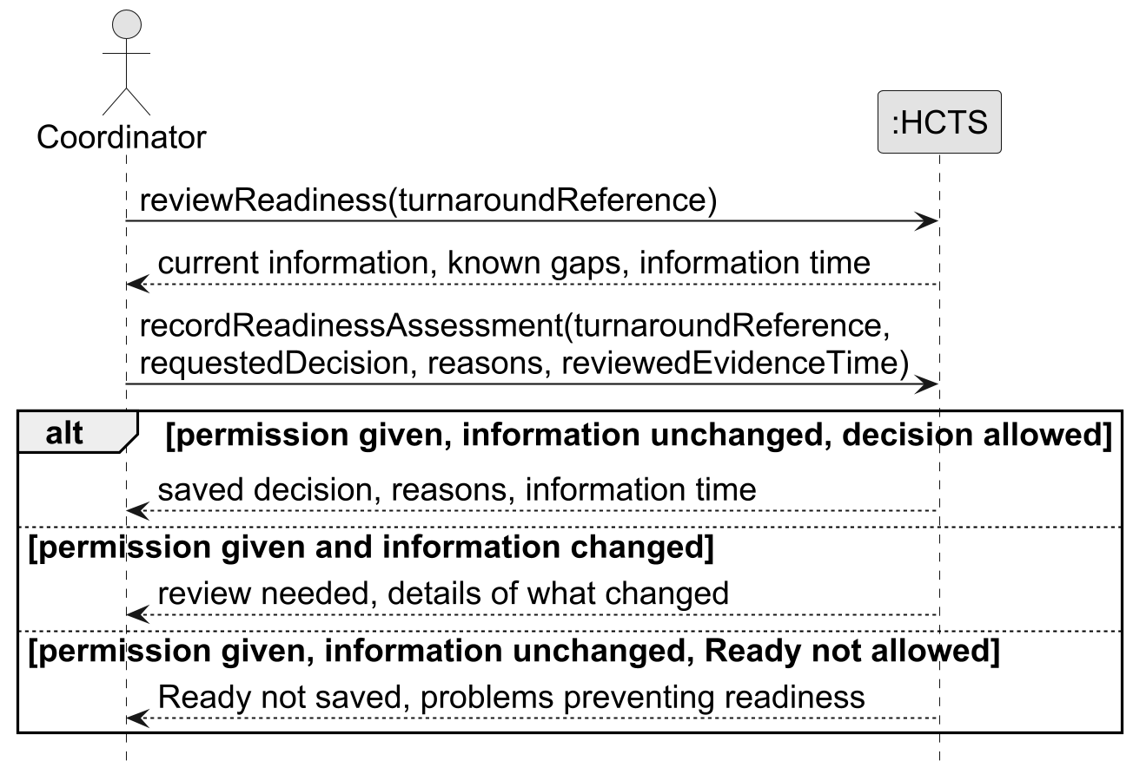
Readiness messages between the coordinator and HCTS. These selected paths assume permission; UC08 also covers refused access and failure to save.

B2 Operation contract what changes after a request
Part | Description
Operation | recordReadinessAssessment(turnaroundReference, requestedDecision, reasons, reviewedEvidenceTime)
Links | UC08 steps 3-6 and paths 3a, 4a, 4b; FR10; GH01; A04, A08.
Before the request | The Turnaround exists, the person is identified and the review information has been provided. Permission, current information and readiness conditions are checked during the operation; they are not assumed to be true.
Changes after success | A ReadinessAssessment was created. Its decision, reasons, assessedAt and evidenceAsOf values were set. It was linked to the Turnaround and the StaffMember who decided. Earlier decisions and unresolved Concerns were kept.
Current result | The saved decision gives the current readiness result until a relevant change requires review under A04. Cleaning completion stays separate.
If refused | No ReadinessAssessment is created by an attempt that fails permission, uses old information or requests Ready while a known problem prevents it. The reason is returned. UC08 says what happens next.
Meaning | These statements describe changes to the domain objects. They do not prescribe database tables or a storage method. [L02]

B3 CRC cards who knows what and who does what
CRC means Class, Responsibilities and Collaborators. A responsibility is something a software object knows or does. A collaborator is another object it asks for help. These cards suggest a possible design for UC08. ReadinessCoordinator is a software object that handles the request; it is not the human coordinator and does not belong in the conceptual domain model. The other cards build on business concepts already identified. [L01]
Class | What it knows or does | Objects it works with
ReadinessCoordinator | Knows which request is being handled. Asks for permission and current-information checks, then returns the result. | StaffMember; Turnaround
StaffMember | Knows the person's roles and assignments. Answers whether they have the agreed permission. | Assignment, when permission depends on a job.
Turnaround | Knows its times, tasks, reports and earlier decisions. Checks whether information changed. Creates a new decision only when the request is allowed. | Stay; Task; LinenRequirement; Inspection; Concern; ReadinessAssessment
Concern | Knows the problem, whether it is resolved and whether it prevents readiness. Explains what remains open. | Turnaround; Inspection if the problem came from an inspection.
LinenRequirement | Knows what linen is needed and what was used. Keeps reserved supply separate from need and reports any gap. | LinenReservation
ReadinessAssessment | Knows the decision, reasons, information time, person and turnaround. Keeps that decision as history. | Turnaround; StaffMember

A short card walkthrough starts when ReadinessCoordinator receives the request. It asks StaffMember about permission, then asks Turnaround whether the reviewed information is still current. Turnaround uses its related tasks, linen needs, inspections and concerns to check the requested decision. When the request is allowed, it creates a ReadinessAssessment linked to the turnaround and the person who made it. A refused request gives a reason and creates no decision record. This is a proposed division of work, not executed code.
The lecture calls several of these choices GRASP principles. Information Expert means placing a responsibility with the object that has the needed information. Creator helps choose which object should create another. Controller handles a request from outside the system. High Cohesion means keeping closely related work together. Low Coupling means limiting how much objects depend on each other. Here, the request handler asks Turnaround for a decision instead of copying all the work and linen rules into itself. [L01]

B4 Object oriented ideas naming and change
A class describes a kind of object; an instance is one particular object. For example, Property describes cottages, while P04 is one cottage with its own details. Abstraction means keeping the details needed for the current problem. This model records bed arrangements but does not model every piece of furniture as a separate object. Encapsulation means protecting an object's data through its behaviour. In a later design, a linen reservation should be created through the stock checks rather than by changing quantities without those checks. [L14; L20]
Inheritance describes an is-a relationship between classes. It is not needed simply because people have different job titles. A temporary worker could also be a cleaner, so roles are a better fit here than fixed worker subclasses. Polymorphism means different kinds of objects can answer the same request in their own way. There is no confirmed need for that structure in this scenario. These lecture ideas have been considered, but adding them without a real need would make the analysis harder to understand. [L14; L17]
Names should explain their purpose. ReadinessAssessment means a recorded decision about readiness; it does not mean that cleaning is complete. LinenRequirement means what is needed, while LinenReservation means what has been set aside. The Rick's Guitars lecture also helps separate an individual item from its descriptive details. Here, Property keeps the cottage's identity while PropertySetup keeps the preparation details that can change. The analogy guides the choice; it does not add guitar-shop requirements to this scenario. [L12; L18]
The Single Responsibility Principle means that a class should have one main reason to change. The object handling a readiness request should not also format owner messages and manage linen stock. Refactoring means improving code structure without changing its intended behaviour. If later code repeated the free-stock calculation, Extract Method could give it one clear home. Move Method could place it with the object that knows the stock facts. Replace Temp with Query could replace a repeated temporary calculation with a named question. No code refactoring is claimed here. [L13; L15; L16; L21]
The two Head First chapters support checking what people actually need and returning to the analysis when requirements change. In this scenario, an earlier arrival is a useful change to walk through: it affects the working window, the staffing plan, the owner update and possibly readiness. The same rule should not be copied into several unrelated places. Keeping clear responsibilities and links makes it easier to change the rule once the company supplies the missing answers. [L08; L09]

Appendix C Supplied sources
Only the supplied scenario, brief, lecture files and lecturer guidance were used for the subject matter. The table explains where they were applied. Page counts refer to the supplied PDF files, not printed book page numbers. L10 and L11 are identical copies and are not treated as separate evidence. The supplied lecturer answers are labelled T. PlantUML was used to draw the diagrams; it did not supply business rules or course content.
ID | Supplied source | How it is used
S | SAAD71000_CA1_Scenario_12_Holiday_Cottage_Turnaround_Service.docx | The holiday-cottage facts summarised as E01-E14.
B | CA1 Individual Requirements and Domain Analysis, supplied pasted text | The required report, stories, diagrams, examples, links and reflection.
L01 | CRC Cards and Responsibility Assignment.pdf | 37 pages. Responsibility cards and who should do each part of the work (B3).
L02 | 10_Operation Contracts and System Operations.pdf | 26 pages. What changes after a system operation succeeds (B2).
L03 | 09_System Sequence Diagrams.pdf | 40 pages. Messages between a person and the system (B1).
L04 | 07_Detailed Use Cases.pdf | 45 pages. Detailed use case, alternative paths and acceptance examples.
L05 | 06_Domain Modelling.pdf | 38 pages. Business concepts, attributes, relationships and numbers on links.
L06 | 05_Finding the Objects.pdf | 34 pages. Finding concepts and deciding which to keep.
L07 | 04_From Requirements to User Stories and Use Cases.pdf | 42 pages. Actor goals, user stories and links between analysis parts.
L08 | Head First OOAD Chapter 3 - Requirements Change.pdf | 34 PDF pages. Following the effects of a changed requirement.
L09 | Head First OOAD Chapter 2 - Gathering Requirements.pdf | 56 PDF pages. Understanding needs, different paths and missing answers.
L10 | 03_Understanding the Problem Stakeholders and Requirements.pdf | 36 pages. Problem, scope, stakeholders, requirements, priorities and unknowns.
L11 | 03_Understanding the Problem Stakeholders and Requirements (1).pdf | Identical copy of L10; no extra evidence counted.
L12 | OOAD07_Rick's Guitars.pdf | 10 pages. Separate a cottage's identity from its changing description.
L13 | 14 OOAD09- OOprinciples.pdf | 14 pages. Give each class a clear main responsibility.
L14 | 13 OOAD08 - AEIP.pdf | 6 pages. Explain abstraction, encapsulation, inheritance and polymorphism (B4).
L15 | 12 OOAD08 - Refactoring Techniques.pdf | 7 pages. Explain where refactoring could help later code (B4).
L16 | 12 OOAD07_OOprinciples.pdf | 5 pages. Keep related responsibilities together (B4).
L17 | 09 OOAD05 Inheritence.pdf | 17 pages. Avoid worker subclasses without a real need.
L18 | 06 OOAD02 - Meaningful Names.pdf | 14 pages. Choose names that explain their purpose.
L19 | 08 OOAD04 - UML Notation.pdf | 12 pages. Use UML labels and relationship numbers; follow L05 for the domain model.
L20 | 07 OOAD03 - Core Concepts.pdf | 24 pages. Explain classes, individual objects, data and behaviour.
L21 | 01 OOAD01 - Clean Code.pdf | 13 pages. Clear names, focused responsibilities and no repeated rules.
T | Lecturer answers supplied separately: use-case detail and unresolved matters | Business-level actions; clearly labelled assumptions, questions, constraints, risks and rules needing confirmation.

1

